Make-up for Session 8: Discipleship and Compassion
Welcome to the Session 8 make-up!
You will need a smart phone and perhaps some editing software. 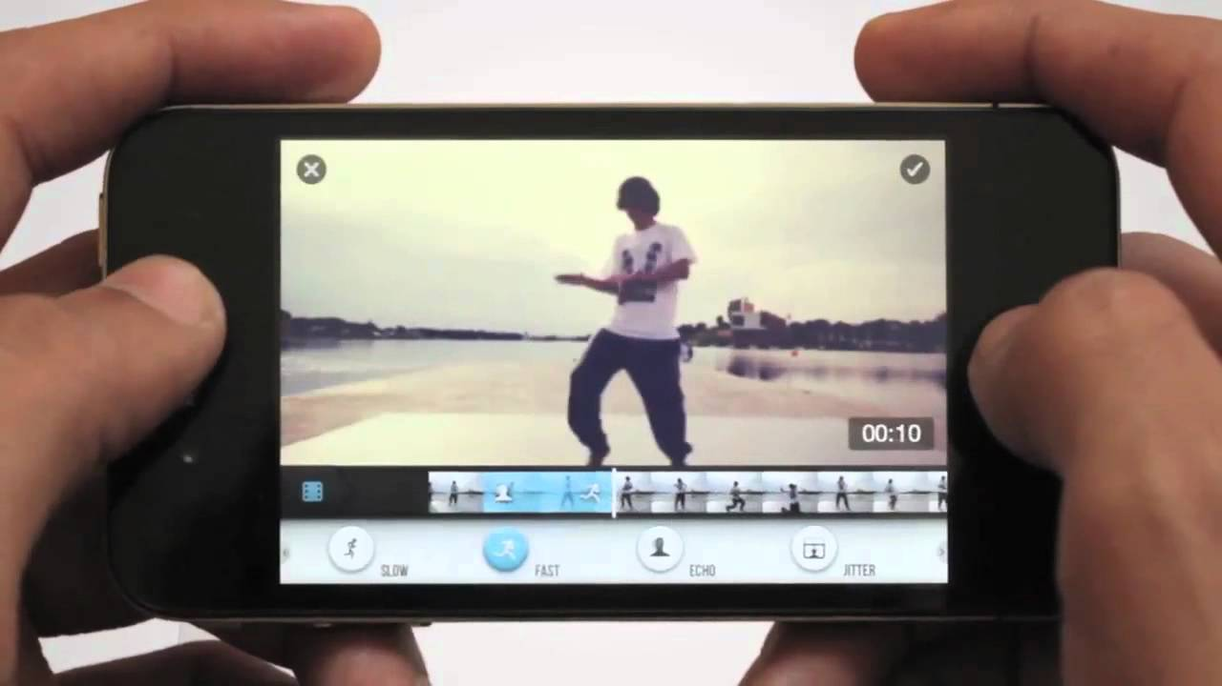

Read the directions below about making an Oral History
Collecting oral histories, or documenting the experiences of people who have lived through a particular aspect of history, allows you to be a storyteller and historian and it this case a Gospel writer.
Your topic is compassion.
Consider a time you witnessed, participated in, or facilitated compassion. Once you have your experience in mind, collect photos of the parties concerned, interview them, and create a video no shorter than 90 seconds and no longer than 5 minutes.
In your video reenact or retell the circumstance where there was harm or hurt. Then tell how compassion was given. Next share your reflections on the event. Finally suggest how you would imagine Jesus’ response to the situation would be and share that at the end of your video presentation.
Once you have edited and completed your video upload it to you-tube and send the hyperlink or send a MP4 to: scunningham@holyfamily.org by April 25, 2021

